

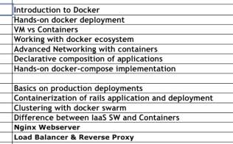

Agenda

Minimal OS

Depends on host kernel

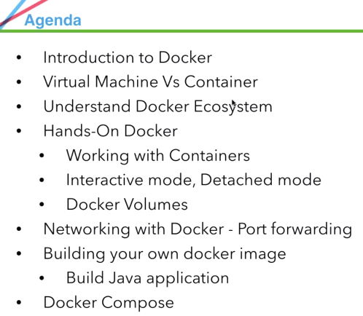

**Docker Compose: Manage multiple hosts of Docker...**



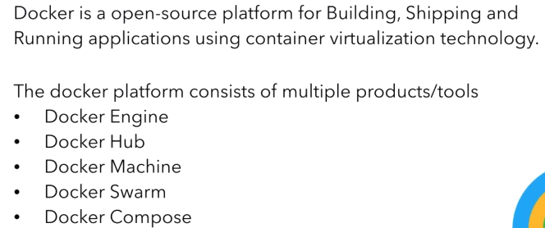

Docker is an open source containerization engine, which automates the packaging, shipping, and deployment of any software applications that are presented as

* lightweight,
* portable, and
* Self-sufficient containers, that will run virtually anywhere.

**A Docker container is a software bucket comprising everything necessary to run the software independently.** There can be multiple Docker containers in a single machine and containers are completely isolated from one another as well as from the host machine.

In other words, a Docker container includes a software component along with all of its dependencies (binaries, libraries, configuration files, scripts, jars, and so on). Therefore, the Docker containers could be fluently run on x64 Linux kernel supporting namespaces, control groups, and file systems, such as Another Union File System (AUFS). However, there are pragmatic workarounds for running Docker on other mainstream operating systems, such as Windows, Mac, and so on.

There are 3 important components:

1. **Build:** We can install dependencies and package it.

Let say python: We install python and its dependencies, install application…And build an image

1. **Ship:** We ship that image to other place. We put on centralize repository, from where others can take it.

(Shipping is like repository…

Like putting code on GitHub repo and others can take it

Similarly, we put image on DockerHub and others can take it).

1. **Run:** That image, we can open it and run as a container using container-virtualization technology.

Docker hub: Central repo.

Docker Machine, Swarm, and Compose: 3 tools in Orchestration.

Docker CE🡪Community Edition->free-> every image. Even we can put our image in public repository, anybody can access

Docker EE 🡪Enterprise edition🡪Paid🡪Give only official and tested images

Why we need Docker/Containerization?

Feature wise: no difference

What is Container??

Way back, when Application Development got started, Applications are installed on physical servers...

If we need another version of Software (Linux/windows) or different version of application (1.1/2.0) or another application. We need another set of hardware.

Physical servers

(1990-95) --No VMs …Only physical machines

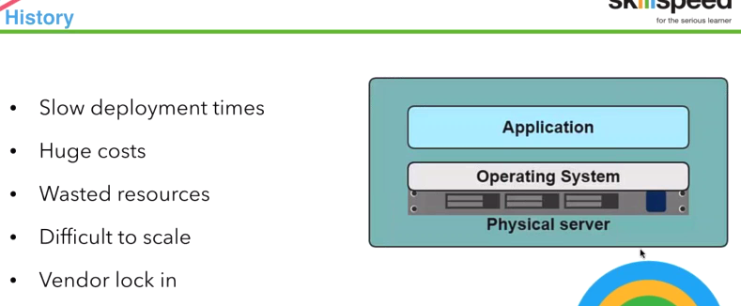

**Huge Cost:** because of physical setup we need

**Waste resources:** Just for application we need everything like RAM.

**Difficult to scale:** If application is used by large no. of people…We need larger server. That physical machine is gone we need to purchase new one with better memory (scaling up is very difficult)

Vendor lock in: If we have Red hat Linux, It’s difficult for license cost and move licenses.

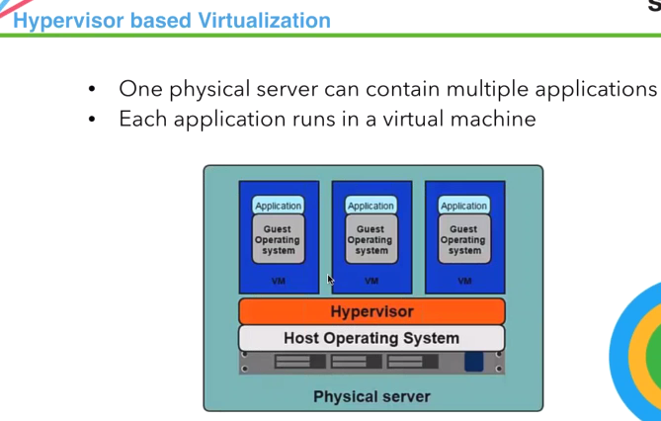

Virtualization

**One physical machines🡪Different OS flavors-> multiple applications on 1 m/c.**

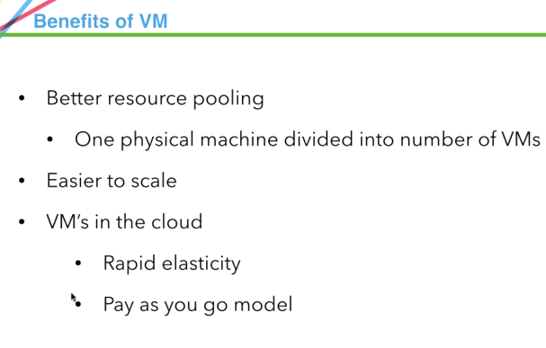

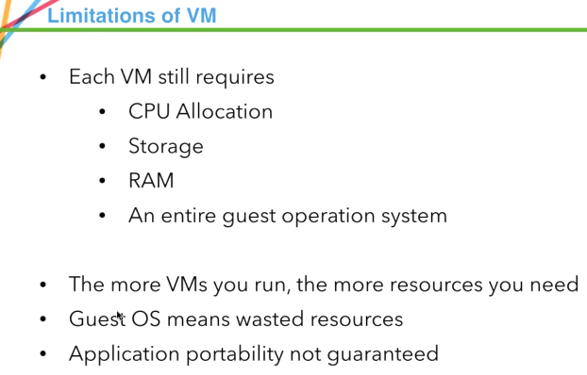

**Lot of resources for creating 1 VM..In my desktop, I cant install more than 2 VMs**

**More Vms=>more resources**

**Guest OS=>waste resources..**

**In physical m/c, we are creating VM and installing OS, which is taking huge recourses for just running applications.**

**For just running APP, we don’t need that huge setup of OS**

Application Portability

Application Portability not guaranteed.

If a developer we fix something, build & test it in our machine. It’s checked into server and QA/system-> click & run--🡪 fails.

Now problem with code or environment??

It runs in DEV env, why not in QA?... Sysadmin may problem with Code.., because everything u said is setup..

-- Application should be portable if same set of dependencies and configurations, available in other machines.

Java, unit, etc are manually done..

|  |
| --- |
| **Can we application without OS??**  **We can run application, that container uses host OS** |

What is Virtualization?

Virtualization is a combination of software and hardware engineering that creates Virtual Machines (VMs) - an abstraction of the computer hardware that allows a single machine to act as if it where many machines.

* Without VMs: A single OS owns all hardware resources
* With VMs: Multiple OSes, each running its own virtual machine, share hardware resources
* Virtualization enables multiple operating systems to run on the same physical platform
* **The main disadvantages:**
* When multiple virtual machines are simultaneously running on a host computer, each virtual machine may introduce an unstable performance, which depends on the workload on the system by other running virtual machines;
* Virtual machine is not that efficient as a real one when accessing the hardware.

**Pros**

1. Ability to run more than one OS simultaneously
2. Flexibility. You can install/reinstall/backup/move your guest OS easily. Also you can manage allocation of resource (Memory, Hard disk), and etc.

**Cons**

1. Performance drop. Usually much slower.
2. Hardware support problem on Guest OS.

|  |
| --- |
| A Roadmap Overview and Update by Rich Uhlig, Senior Principal Engineer, Corporate Technology GroupSession IVTS001 c2006 Intel Corporation |

**Increase uptime**

* **High Availability** – By distributing load across virtualized machines, virtual hosts are able to ensure high availability of applications and data. Even if one server fails, another virtual machine can be spun up with minimal downtime or data loss.

**Scalability** – Virtualized machines allow scalability on demand without adding physical resources, and they can be expanded much easier than in a physical machine. Adding additional RAM to a virtual machine can be done in a few minutes, while it can be up to a day’s work for a physical machine.

- Rather than having to buy new hardware every time you need a new server, you’ll be able to “spin up” a new server in far less time (and for far less money).

* **Backup with Fast Recovery** – Virtualization and cloud computing offer powerful solutions for data backup and recovery. Even if hardware should fail, virtual machines can instantaneously and accurately migrate data to working hardware with little or no downtime.
* **Easy Cloning –**Cloning a virtual machine takes just a few clicks and a matter of seconds, whereas cloning a physical machine can be a serious undertaking.

### Test Environment: One key element in managing a solid infrastructure is to have a test environment to develop and test out infrastructure changes or applications. If this is a physical environment, you’re going to be dealing with some challenges and lost time if you make a mistake. In a virtual test environment, you can easily snapshot a working environment, make your changes, and if it fails, roll back to those working snapshots and try again. UNLIMITED times! You save time, and as such, can implement changes with full confidence that it’s going to work the first time.

* **Simplified management.**Hypervisors will allow you to log into one server and manage all of the servers in that environment. You’ll also get more in the way of statistics and reporting than you would from a physical device.
* **Security.**Security is centralized through the hypervisor software; instead of securing each of your individual servers, you just have to focus on building proper safeguards and controls into your underlying software.

**Improve disaster recovery**

**Isolate applications**

**Reduce hardware vendor lock-in**

**Save energy, go green**



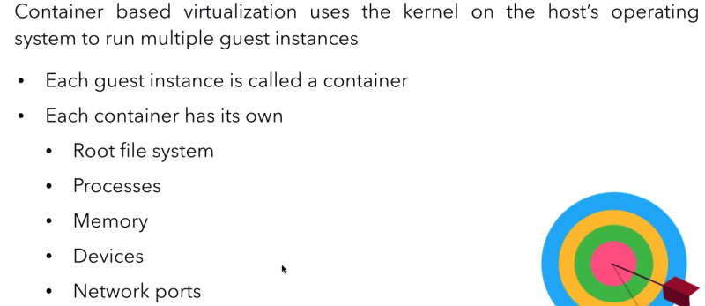

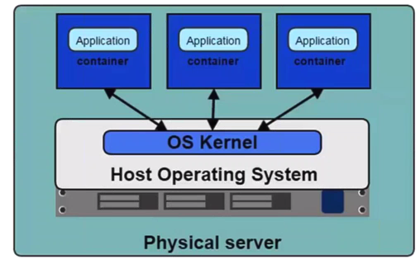

We have 1 physical server (1 physical m/c)-> Host OS (Linux)-> kernel

Now, we create container. Container doesn’t have OS.

Container can use host OS and run application..

Another Container can use Same host OS and run application..

3rd ….etc

For running container, we really don’t need OS.

If we want, On CentOS m/c if we want to run APP on Ubuntu m/c. We can install OS also inside container..

**Can we have one OS, and have 3 env like dev, QA, stage??**

1 OS and 3 Env..,not a practical scenario..

But we can have 1 OS and 3 containers..

In my m/c I hardly able to run 3-4 VM’s. Can run 50 Containers.

Because it’s not like using guest OS.. only host OS.

**WE are going to install Ubuntu OS in Container also..**

Application Portability

One of main adv. Of Docker is:

Application is not portable, when we move it from one place to other. Starts breaking

DEV to QA moved –Breaking.

DEV ,QA works…In stage breaks..=🡺 it is not portable.

Something wrong in code or env or configuration or machine in which we are running or versions of software’s installed are not compatible with what you have tested on...

That means Application is not portable.

Containers🡪 Complete Image, which is complete set of config, moving from one place to another 🡺 application is portable.

Exactly, what I tested in DEV, will run in QA, stage,..

VMs VS Containers

**Should container technologies like Docker replace virtual machines in cloud environments? It depends on the application, operating system, and OS instance.**

**Where we use VM/container?**

**Now things are moving towards containerization...bcz virtualization takes lot of memory, save money, deploy faster,scaleup faster**

. (Speedy way of deploying application)

Lot of application with less weight, lesser memory.

Virtualization has set the goal of bringing forth IT infrastructure optimization and portability. However, virtualization technology has serious drawbacks, such as

* Performance degradation due to the heavyweight nature of virtual machines (VM),
* the lack of application portability,
* Slowness in provisioning of IT resources, and so on.
* 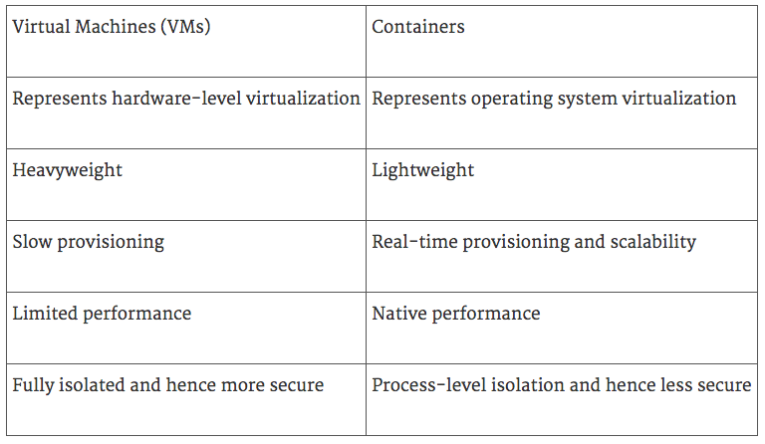

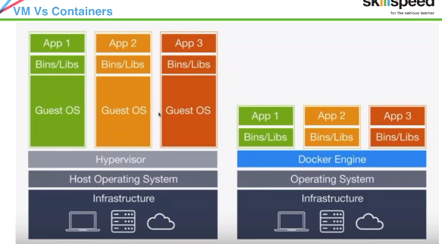

For Container-> Docker Engine

VM-> Hypervisor

Infrastructure/Physical m/C, OS, hypervisor layer which manager machines..

3 Guest OS, 3 APPS.

Docker-> Infrastructure-> OS-> Docker Engine-> Applications are managed.

They don’t have Guest OS.

Container: Applications/ dependencies

Q: Can we increase size of container?

We can actually expand number of containers..

We can use Docker swarm, where we can run multiple containers and manage them.

Q: Do container have memory/RAM?

They have.. cmd also there..

OS it use is host OS.

Under hood

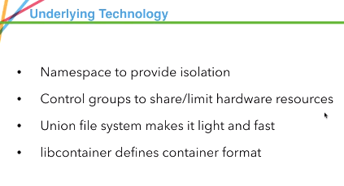

How docker is able to manage Containerization...

These are technologies/features of Linux.

Q: Can 2 container talk each other?

Yes.. Micro services are separate modules/services running.

These services will run on different containers.., and they talk each other.

There are technologies like: Docker Compose, we can run application with multiple containers.., each container talking to each other.

There are commands like link to link 2 containers.

**Q:** How many machines can I run in Docker Engine?

Docker engine is like server.., which is installed in your machine.

Depending on Ram, we can run 50 -100…

**Q :** Can we install webserver, nodeapp on container?

We can install ngnix, etc..

**Q:** Is it possible to cluster in Docker?

Yes.. Without Clustering Docker will be useless.

There is Docker Swarn which helps to manage Clustering easily ..Infact scaling up/scaling down .

Let say we have 100 concurrent users.. Running in 5 node cluster in fine.

But immediately next week we have 1000, now 1000 users may not be able to run on 5 clusters or nodes.We need to scale up..

Scale up to 50...Docker swarm helps in making this easy..



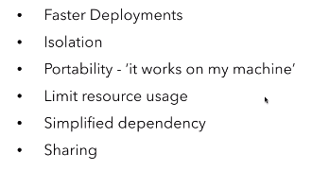

**Faster deployments:**

Say I’m installing Ubuntu on my Docker Container... 1st it will download from Dockerhub.2nd time, when I run another container of Ubuntu. It will not download again.

In fraction of seconds, it will run by using image it already downloaded.

Suppose we wrote application and created image of it.. U change something. It will just add new layer of it.

**Isolation**: Container is isolated other Container from host OS

**Portability**: It works on my machine.. Now not

Developer-> Code-> Fix issue

Java application, we need jre/java.

So, we will create container with Java and deploy application in container and see everything is running fine and no Bug . Now build image out of container. That image u put on server.

QA will pull that from server and when we run container.. The environment exactly with Dev one.. No Question java version/OS differs..because it is within Conatiner🡺Portability. If issue: problem with code.

**Limit resource usage:** It uses most of host OS

Sharing : easy

Q: can we run use local iso without downloading

Docker will run with only images, not iso’s.

Iso🡪 fully blown OS. Images->pretty much compressed, well defined OS.

Install Docker

When we install, all of these are installed.

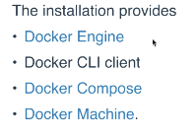

Engine: server CLI: client

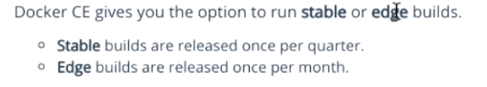

Production: Stable

Docker is client-server architecture.

Installing in Ubuntu

sudo apt-get install curl – y  
curl -sSL https://get.Dockercom | sh

Install Docker package  
$ sudo apt-get install docker.io  
sudo usermod -aG Docker vagrant

Check installed or not:



Vagrant:

Easy way to create Virtual boxes. There are predefined boxes of these Ubuntu/other OS.

Vagrantfile_>which box going to use, Ip address.

**Q:** Can we define gnome installation in vagrantfile??..Yes

**Q:** IS vm clone using vagrant.

No.. Vagrant also have vagrantbox. Vagrant boxes already available..Pull them & create VM.

FS-> Union file system

Volume technology-> To share files b/w host and container

Terminology

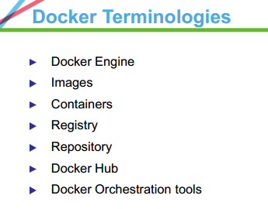

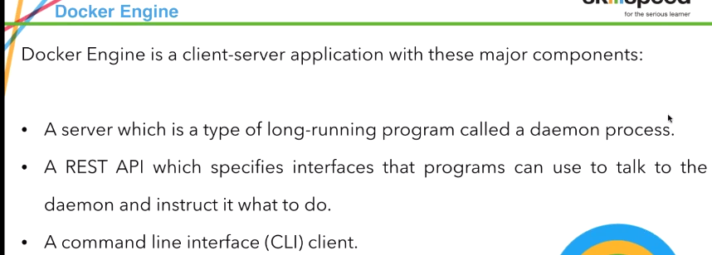

Docker Daemon

REST API: Interface b/w client and server done by this.

RESTAPI: Inbuilt API provided by docker.. It takes input from docker CLI and gives to daemon.

Daemon: a [computer program](https://en.wikipedia.org/wiki/Computer_program) that runs as a [background process](https://en.wikipedia.org/wiki/Background_process), rather than being under the direct control of an interactive user.

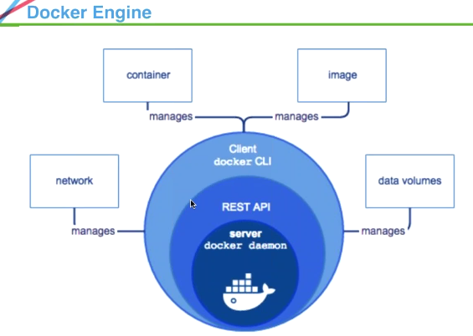

At core, we have server.2nd layer RESTAPI, 3rd-> CLI.

Through CLI, we can manage containers, images, volumes, and network..

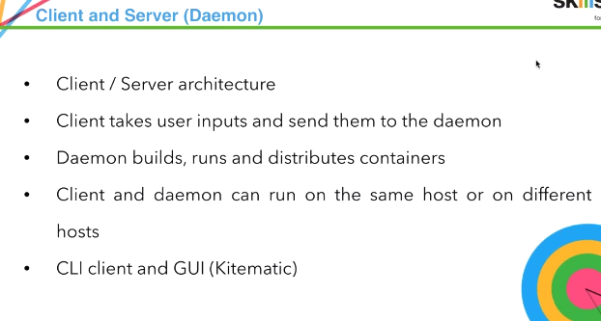

Kitematic – Docker GUI client

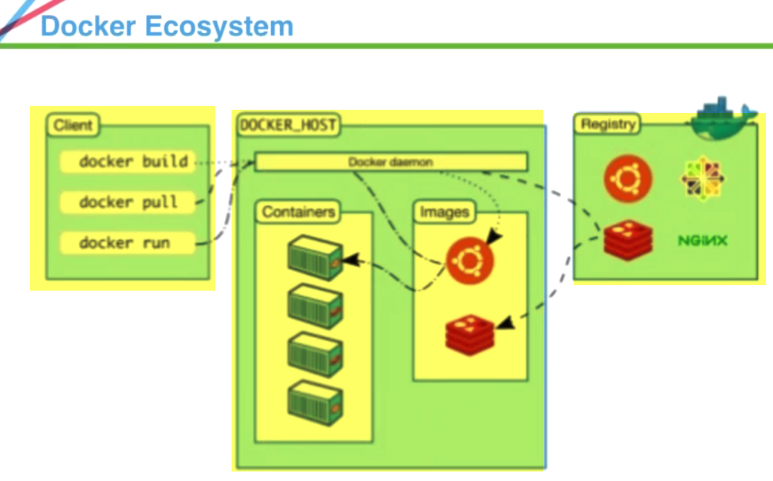

Client

Docker HOST: That runs daemon

Registry.

Client, daemon are in separate boxes, for our case in same m/c as it is installed in same m/c.

Client: run commands

Docker daemon: Go to server pulls from registry, bring image on local machine, run and container out of images..

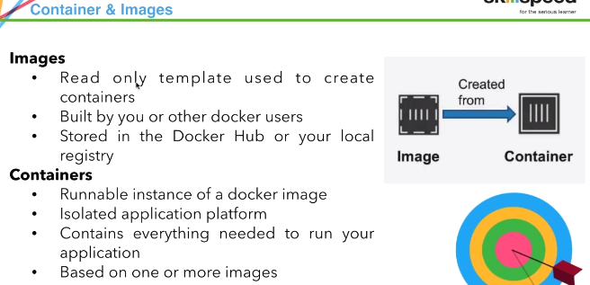



Images: Read-only.. U cannot work on images.. or change image..

You can create new image from that image.., but cannot change them.

From image, we create container.



Base layer: debain, next we install apache🡪will create image layer🡪 install vim🡪 create image layer🡪 Finally it will build complete image

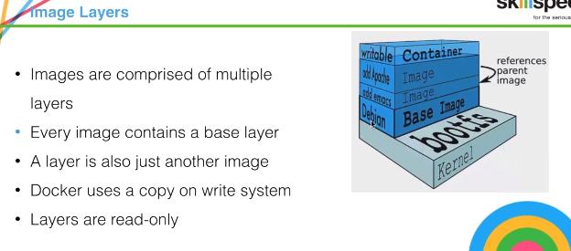

Base never changes🡪 when changes made🡪top gets added up.

Images layers that are created are out of images only.

Base image-> do something🡪 Gets image layer created

On image🡪 do something🡪 Gets image layer created

On image-> do something🡪 get image

Writable layer: Whenever you crate container

There is always writable layer on top .. On writable layer we can add something(emac)🡪image layer create🡪 on top Writable layer🡪 add something(vim)🡪image layer created🡪 on top writable layer.

On layer on top of other🡪 pack it as image.

**Q:** Does image have OS?

Yes.. There is image of Ubuntu, centos etc

**Q:** Is image ID same?

No.. Image ID always differs..

Base image—ID🡪 new layer added🡪 different ID.

**Q:** To create image, we take other image as baseimage?

Baseimage🡪install vim🡪create image layers

Q: Does every installation create image

Yes.. Whatever installed, creates image layer and stored as image

Docker Registry

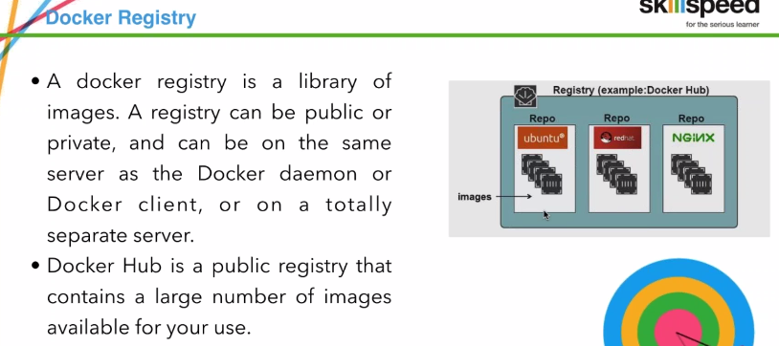

**Q: Containers are created dynamically when images are pulled & run?**

Yes.. When we exit, container will shutdown..

Docker hub in a registry.., where u can find all repos.

Repo& image: **Repo+ tag=image.**

Ngnix -> webs server.

**Q:** Can I ship image with c can ontainer to other Docker host..Is is possible to make permanent container..

Image can be ship.., Image is built from container .., & can ship to another host.

You can upload to dockerhub, and people can take it

**Q:** Where can I ship images to?

Other than dockerhub also we can ship ..We can create local registry.

Ip:\\registry

**Q:** Dockerhub is hosted on server.

Docker people maintain it..& made public..

**Q:** When we run image, new container is created.

Yes..

**Q:** Private hub create..How to?

There is registry image itself,, If we download.

It will run on some localhost: 5000 (port not sure).

There is actually docker image of registry.

If I want to run one container, I need an image.

That image we find from dockerhub..

**Hello world container..(For practice purpose created)**

**Create container:**

[vobadm@devosp1 Desktop]$ docker run hello-world.

2 things happen..

* 1. 1st changes locally if hello world image exists
  2. If not there, download from by default dockerhub

Run image and displays text –helloworld.

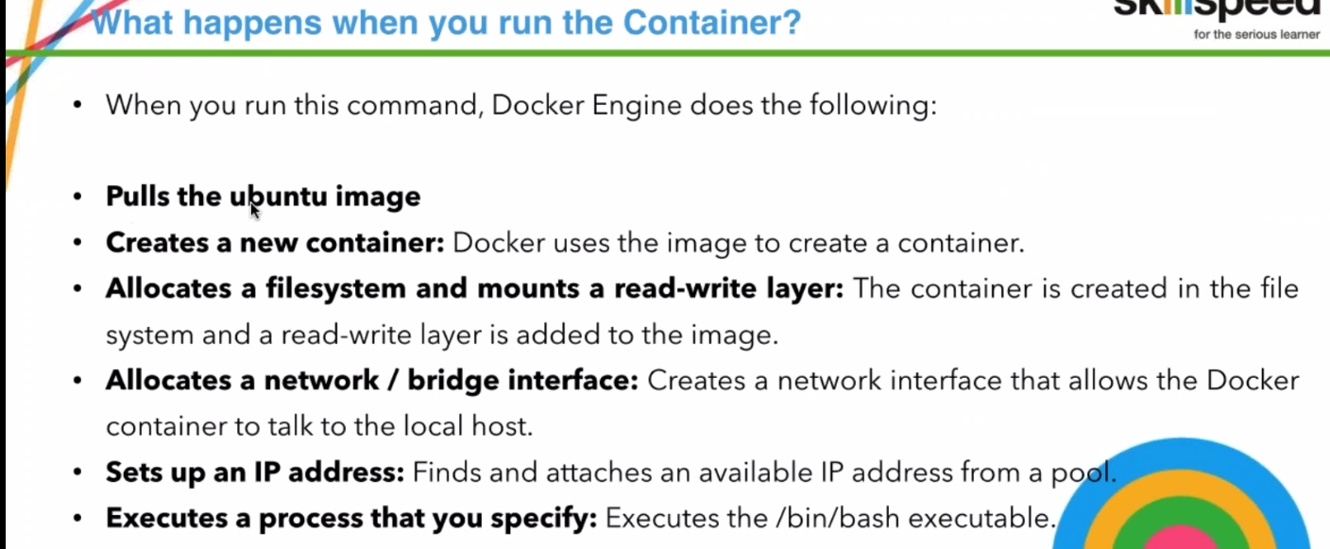

**Whenever we run container form image, it will do its work and just exists. Unless we mention not to exit.**

See running containers🡪 docker ps

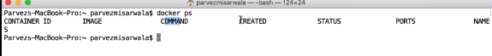

Container ID, image, What command u want to run, created date, status ,

name

Created image, run container-> did it work-> exited

**Q: Docker engine /docker daemon same🡪 as service/process.**

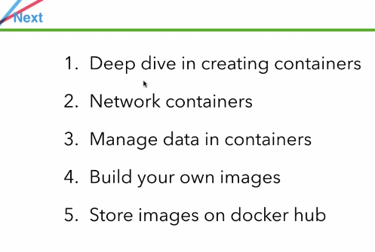

* Networking: Port forwarding
* Manage data in container: If u run application, and have some data available, Like log file.. how u take those
* Build own images—Using Dockerfile

🡪Docker run ubuntu:14.04

Ubuntu have lot of images..12.04.14.04,16.04,latest..

If we don’t provide tag.., it will get latest default.

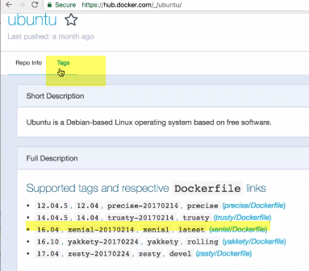

So when downloading, always use specific versions.

Otherwise problem would be : every time you create container there will be new one.. (BECause latest means ever changing)..

If we keep doing latest in docker run/Dockerfile.., latest might get changed.

Downloads something..& program may not run..

Q: Can we download ubuntu 32/64 bit..

Check it..on ubuntu website—and trusty name

Docker run ubunru:14.04🡪 Download image, created container & exited

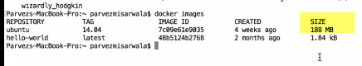

If we create 4 containers, it doesn’t take 4*188 MB.. Only 188MB.

Interactive mode:

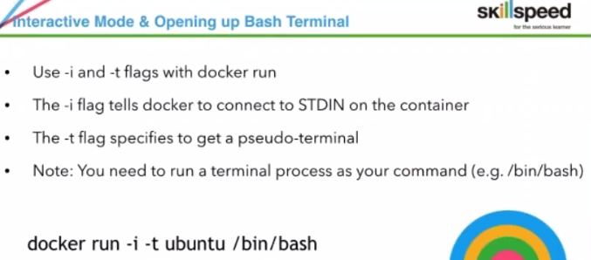

i-> Tells docker to connect to STDIN (interactive mode)

t🡪 gives us sudo terminal, bash

Started in std input mode, and gives bash terminal..

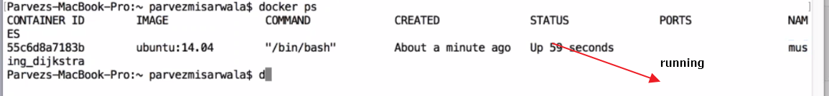

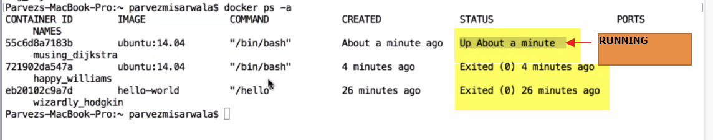

**Q:**Does image have ipadress..

Yes.. Container will have Ip.., not image

Inside container of ubuntu:

Apt-get update

Apt-get install git

Git –version

Q: What is RAM, CPU, HDD of container..

….???

**Q:** Can we run 2 ubuntu containers with same IP??

…???

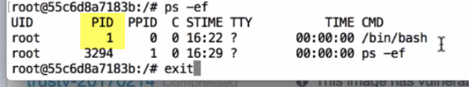

If exits .., container exists

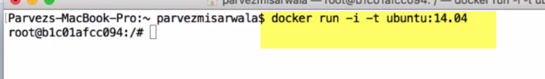

Now, Do we have git image??????

Whenever we say docker run, we are running from image..

Image doesn’t have git…It will use fresh image of ubuntu downloaded locally..

One image.. can have many containers..

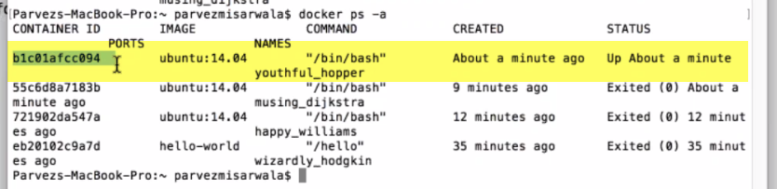

This above container have git..



If we start same command again, it will use fresh image of ubuntu downloaded locally ---------------

No…..Say, If I want to have git+ubuntu configuration for everyone...

Then we need to start with ubuntu-> install git🡪create image out of it

That image can be done using dockerfile/docker commit

I started container from new image-🡪 So no git is there



---------------------------------------------------------------------------------------------------------

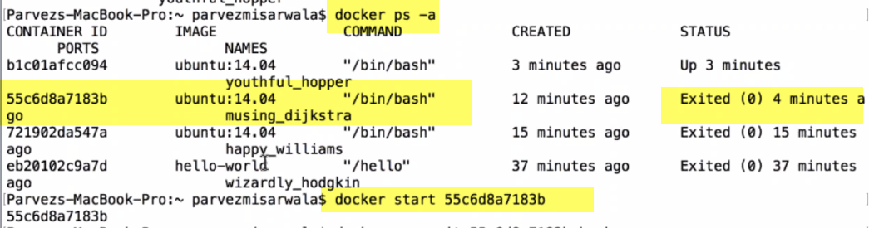

Exec command🡪 allows to get into running container

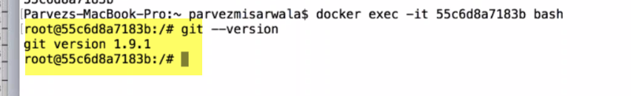I ran in container, git is installed..

**Q:** Can we start old containers…??

Yes.. docker start cid

**Q:** When to run docker run and docker start?

Run-> When we are creating container from image

Start-> When we are want to start old container, which is exited..

**Q:** How to keep container running all time..

* 1. There is way to run using interactive mode.
  2. Detached mode

**Q:** How to ship container?...We ship image never container

We can put on docker hub.. Other people can download it.

If we want to ship container.., build image out of it & upload it.

Q: When to use docker pull??

Actually, When we say docker run…, it pulls image & runs.

Let say.., I only want to download image & don’t want to run ..just use docker pull

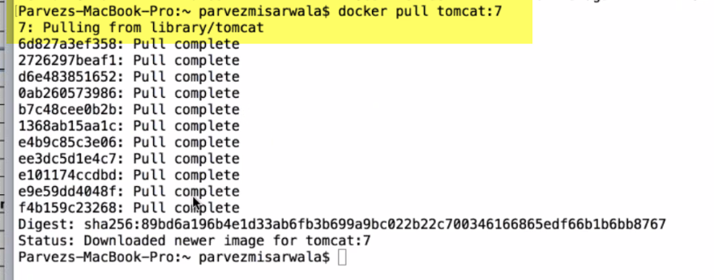

It will just pull image and keep it here.. Doesn’t create container here..Pull is only to download

**Q: When do u use docker pull**

In real time, when u don’t want to spend time in execution.. It saves time

Once u can pull all images u want. Whenever u want run those.

Q: What is docker push??

When we want to push to docker repo..

Pull image from docker repo to locally on our machine is: **docker pull**

If I have my own image, and want to push to server is: **docker push**

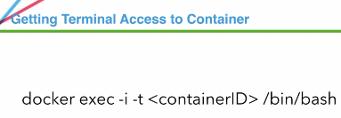

Port mapping & forwarding

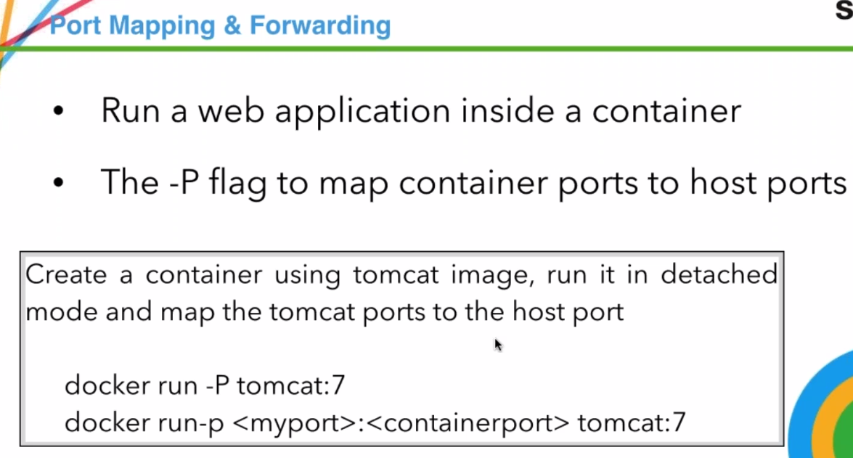

Port mapping: In real time most of our applications are web applications.

These web application run on one or other server with a port.

Without port, web application won’t run web app

When we run inside container, port is inside container.. what about machine(outside)..???

We are not going inside container and run application..

We will be running application from browser..

How to map container port with host port??

Docker allows using flag p

Docker run –P tomcat:7

P🡪 customized one

P->auto mapping of port.. Docker automatically define some port

Tomcat always runs on default port 8080.SO That’s default port of container...

With –P, docker maps default port(8080) of container with host port.

Host port b/w: 4915 to 65535

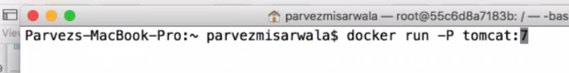

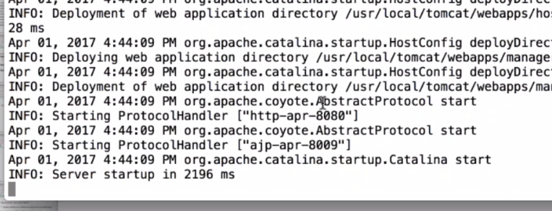

Tomcat started..

On new terminal of host m/c:

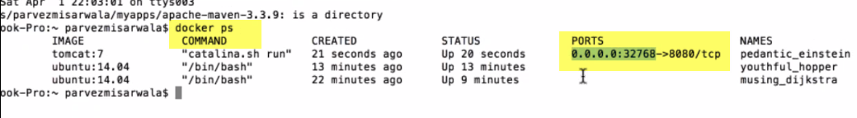

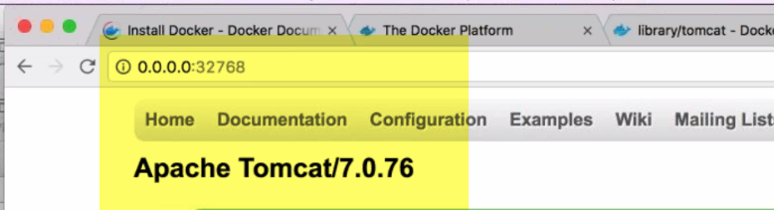

This tomcat is actually installed inside container.

This port 32768 of host is mapped to 8080 port of container.,done by default P.

If we want tomcat to run locally(host m/c) we need to map port in container with host m/c

Q: If u are to scale up tomcat server, and add ports to balancer.. How do you auto-discover ports docker has used??

This is possible using docker swarm.. How it manages different posts.

For ex: if I have cluster of 5 nodes, how can this be managed using docker swam.

Q: Can we change tomcat port from host

Yes.

Q: can we access tomcat using containerIp:8080.

Now, 1.) how to change port..

2.)Customize port of tomcat

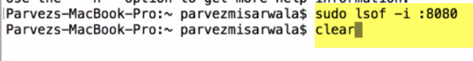

Check if anything running on port:8080



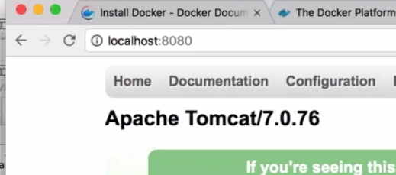

Run in background (detached mode) -d



* 1. Detached mode

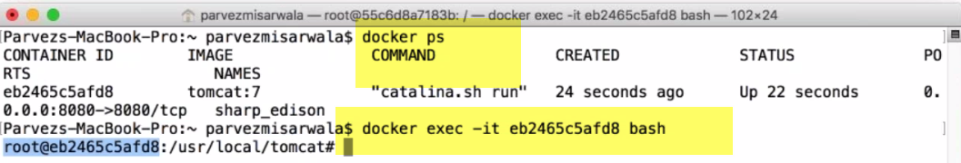

* 1. Container running
  2. Enter into container bash.. Exec allows to attach to tomcat

- it 🡪 allows to use bash terminal

* 1. Now, inside tomcat container
  2. If I want to copy war file.., can copy it
  3. Change configuration:

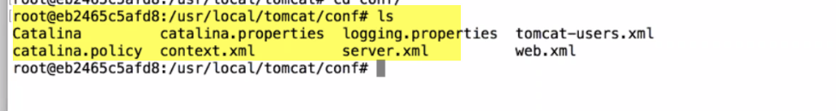

**Q:** If I have 5 container. Do they have same IP?

No... 5containers will have different ips

Managing data

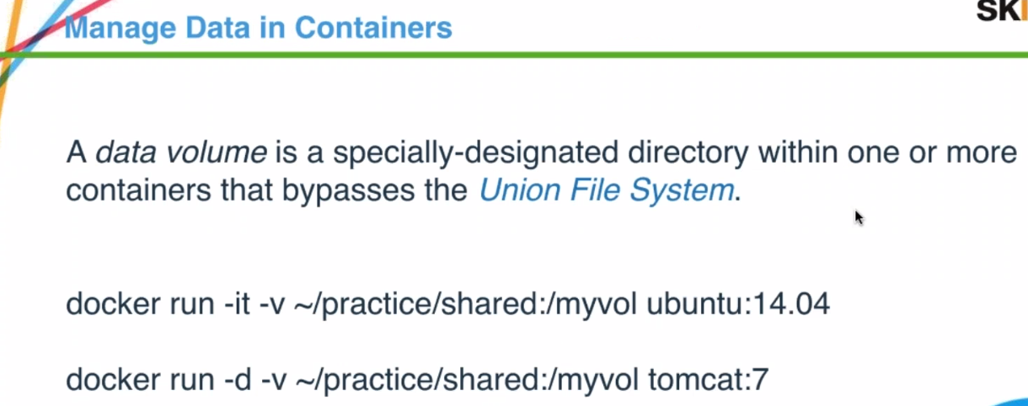

Union FS: File system within Container.

We don’t see on local host m/c

🡪Let say generating log file or say generating data and want to use it for other container creation..(what to save data)

Possible using volumes

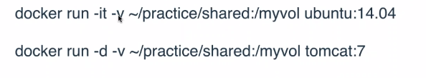

host dir: container dir (if container dir not available.., it will create directory).

**Whatever data, I put in Container directory, will actually be stored in host directory.. Even if I exit container.., file remains**

We have application generating log files..,& want to store them in host dir.

We can map log dir.., to host dir.

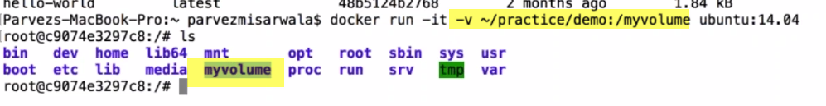

Create own image

* 1. Myvolume dir created.

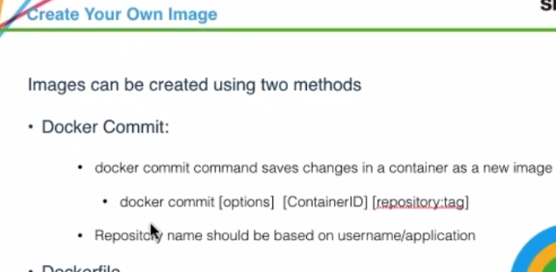

1.)Lets us run container.., make changes (config )to it.., & then make it as a image

2.) Create java application using dockerfile, and create image out of it.

--------------------------------------------------------------------------

1.))) 1.)Lets us run container.., make changes (config )to it.., & then make it as a image

Docker run –it ubuntu:14.04

C##

apt-get update

apt-get install vim

apt-get install curl

curl 127.0.0.1

exit

H##

Docker ps –a

(get conatiner ID)

Docker commit Cid devopsharish/myimage:1.0

Dockerhubusername/imagename:Tag (good practice)

Tag use: Using this image, if I want to install something else..,like nfs.., we will use tag 1.1

Docker images🡪 image will be present

Docker run –it devopsharish/myimage:1.0

Test: 1.) vim test

2.)Curl localhost

**Upload image:** docker push devopsharish/myimage:1.0

Issue:: Access denied.

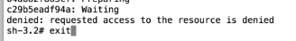

Sol::docker info🡪 do this have timeout period??

Docker login

Username: password

By me??why shouldn’y I try docker pull.docker run now??..may be solution

**Q:** devopsharish/myimage:1.0

**Is myimage will be my repository name??.Tag will be 1.0**

Yes.. myimage will be my repository name

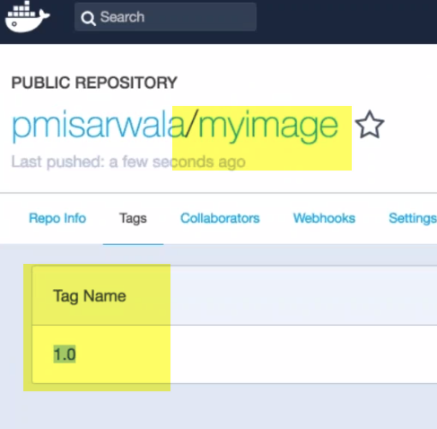

I have pushed image to registry server.. Now anybody from QA team on staging server can pull this image..Run same image

Now, delete myimage from host m/c..Get it from server

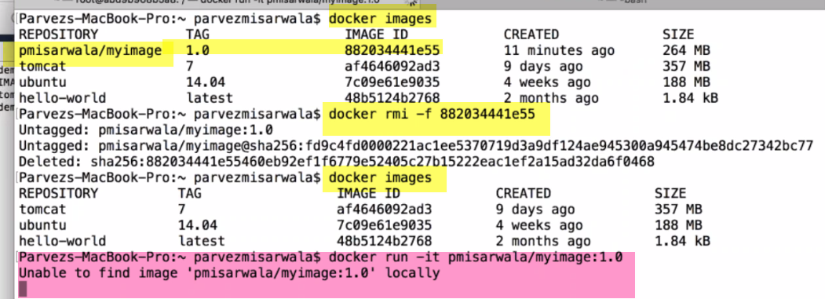

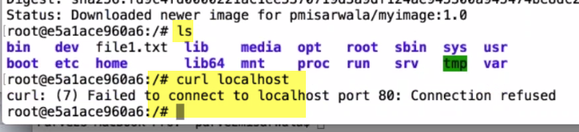

Actually I get same environment.

This is core functionality of docker.

2.))) Creating java application

Dockerfile

Lets create dockerfile and upload to server

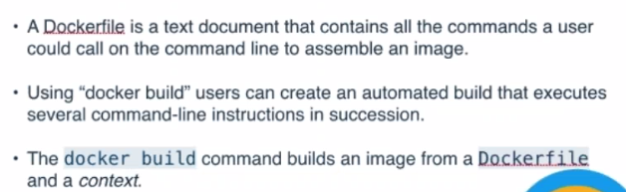

Context: Otherfiles Ex; java files

Highly used m/d of creating image🡪Defining in a dockerfile

Lot of commands,dependencies..etc

Infrastructure as Code:

Instead of configuring everything from UI,., we actually write a script file which configures everything..

In chef-> we write recipe-> configure environment

To create Dockerimage-> we write dockerfile

Download java image->Take java file inside and copy inside container

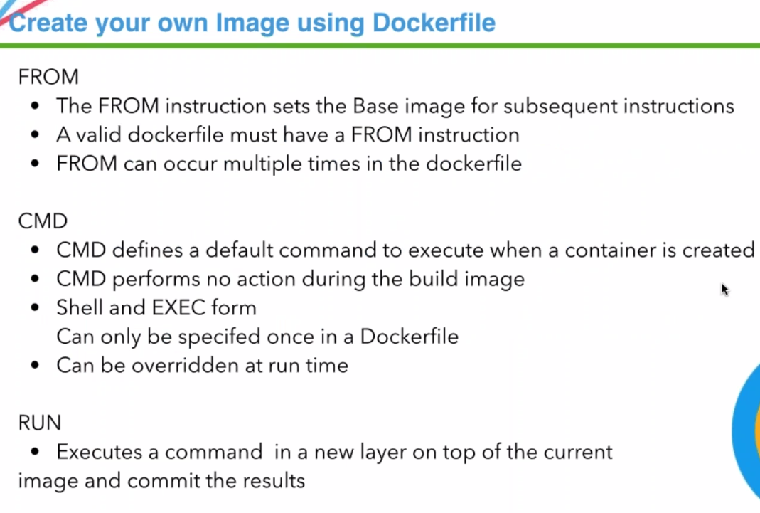

WORKDIR,ENTRYPOINT

1.)FROM🡪1st command and must be present in dockerfile

* FROM-> sets base image
* Docker image is set of image layers.1st image is base image
* **It can occur multiple time**
  1. CMD->defines a default command to run when container runs.

Ex: If we want to run ubuntu container, default command would be bash

For Java application, want to run java pgmname

Cmd is command, we want to execute at run time, when container is created.., not when image is built

Only once in dockerfile, & that is one that executes when container is created.

It can be overridden at runtime..

Let say: when we run conatiner

docker run –it ubunu ping 8.8.8.8

We write curl as CMD in dockerfile.

Ping will overwrite curl in dockerfile

RUN:

Everytime u install, create new layer and commit

RUN apt-get update🡪 install apt-get update on top layer-> commit .

RUM vim🡪 on top layer🡪 downlaod, install VIM-> commit

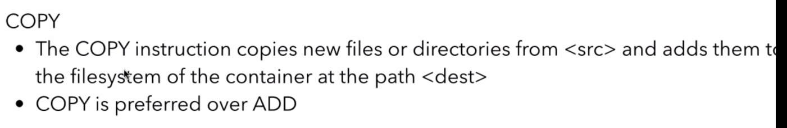

COPY: copy file from host to container..,

To create image & carry those file

1. Simple java application---just printout something

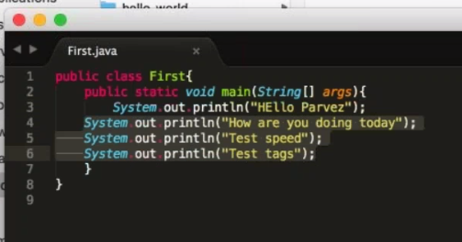

**This one, I want to run through Docker container**

Q: I want to create image without baseimage(or) I don’t want to specify FROm in dockerfile, creating fresh image which is independent

If we want to specify image,which is independent of others, we still need to specify FROM scratch ..FROM should be there..,scratch means nothing

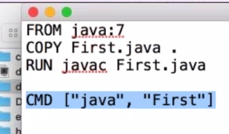

1. FROM java: for this java application, I need java.. I will get image from dockerhub
2. COPY first.java(located in dir. Of dokerfile…, copy to root of conatiner

We can specify src/file

1. Javac will compile
2. CMD will run command..,

when container is created.., if i run java first..to get output

docker build –t pmisawla/javaapp:1.0 .

t-> tag

pmisawla/javaapp:1.0🡪 name of image:tag

.-> location of dockerfile

It will build, but it need location of dockerfile (.--> current dir)

It starts reading dockerfile starting from FROM, build it & give me image.

Layered approach

Pulls java

Commit

Intermediate image created

If we don’t give tag, by default. It will be latest.

(will overridde)

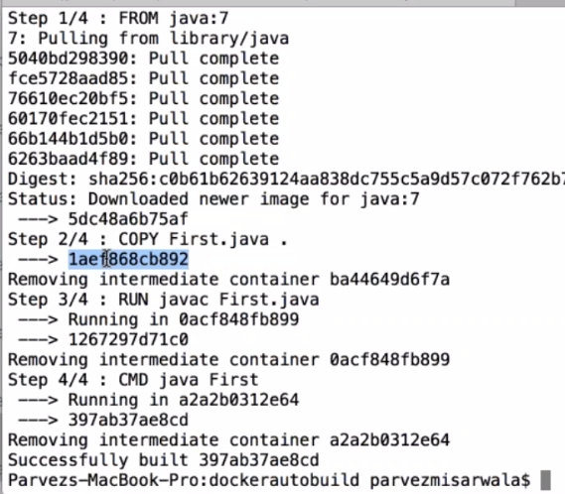

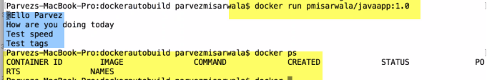

Change source code now(application)

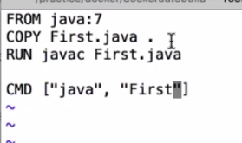

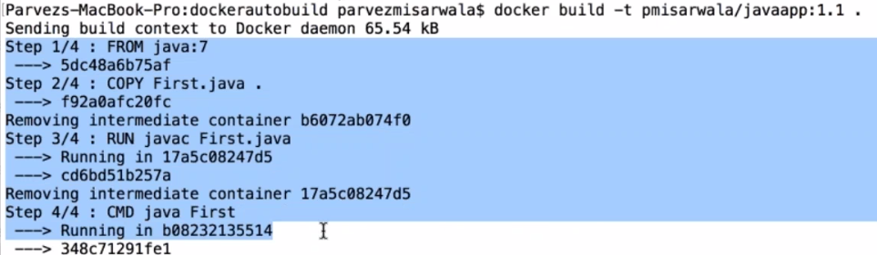

In seconds it will build.., all these layers are already available..



We can override old image also..

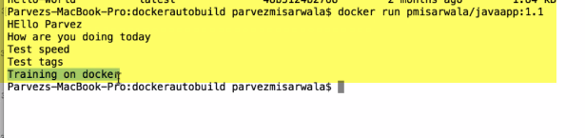

This is manula testing. We can automate this using Jenkins also.

Image will be created.Pushed onto sever..QA team take it and ru n it..

NO issue of java or dependencies..because we are packaging it everything into one.

Q: Any open source to monitor docker containers to test, how much memory it has??

Mail to be send –monitoring tool Ex: kubernet

Kitematic



Docker GUI for windows/mac.

Kinematic integrates with Docker machine to provision virtual box and install Docker engine locally.

We can create containers on our local machine as well virtual machies.

Kinematic: Doesn’t have functionality of creating image.., only managing conatiners.

Start,stop,restrt,delete, ports, volumes, CLI, web preview etc..

Limitations are there.., for basic functionality it is good..

🡪 Click on exe.., To run Docker containers on computer, kitematic starts linux virtual machines

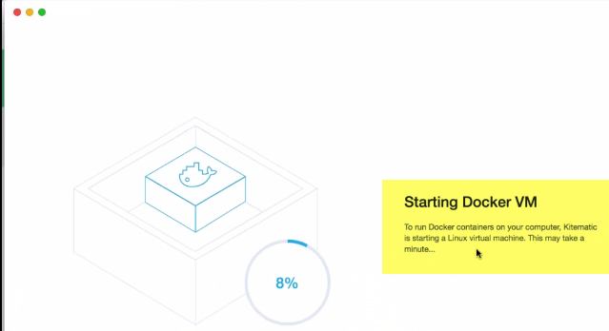

When start kinematic 2 options.

1. can use local VM
2. Build docker host on VM

Creates a VM for me

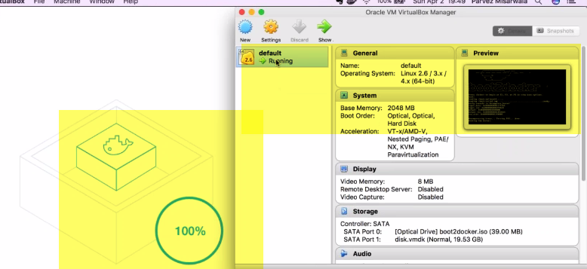

Boot2docker.sio🡪 setup for running docker.

Main UI of kitematic.

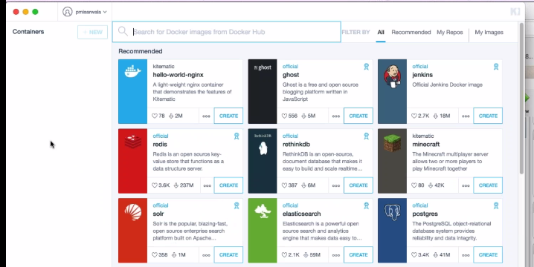

Creating container:

Most official images used..Basic purpose of this tool: instead of writing command to create container, you can do using UI.

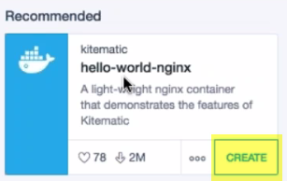

Create-> select tag-> create



Container will be started from this image.



Actually this container will be create in this VM

Commnds-> start,stop, restart, exec.,,,,

Kinematic: Doesn’t have functionality of creating image.., only managing conatiners

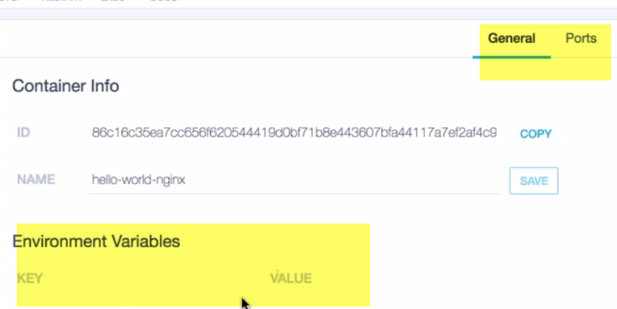

We can define env. Variables, ports etc..

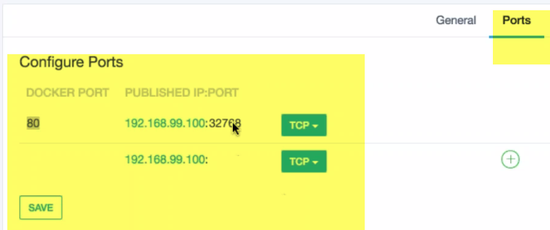

By default, port 80 is mapped to 32768

192.168.99.100🡪 ip of VM.

In browser,

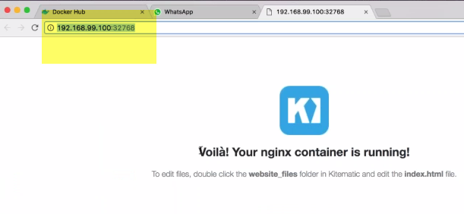

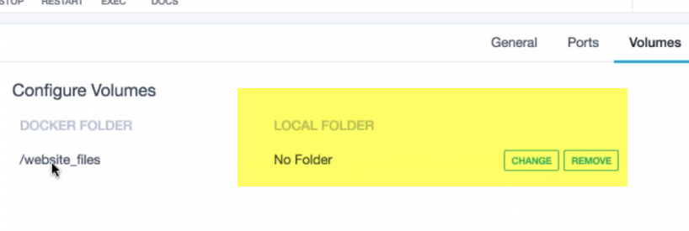

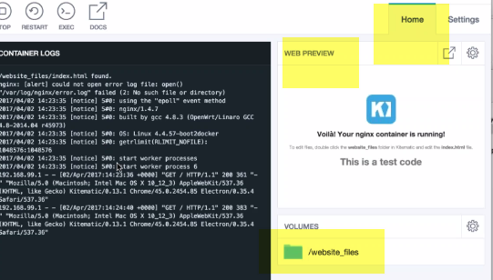

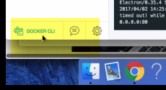

Helps moving b/w UI & CLI

Q: How to upload our container to Kinematic??

Using kitematic, we can create containers. No concept of uploading.

Kitematic is on our m/c. If there are images in our machines locally, it will show them..

**Q:** We designed container in MAC, I want o see them in kitematic

You can create image of it, upload on github.., download on kitemmatic.

This is integrated with dockerhub, & that downloaded image can be used in kitematic

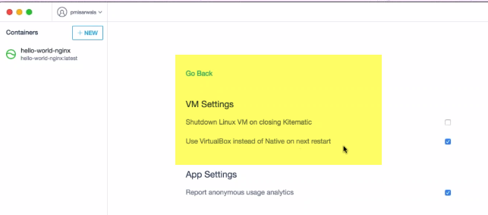

If I uncheck this, on next restart it will give me all images of my local m/c.

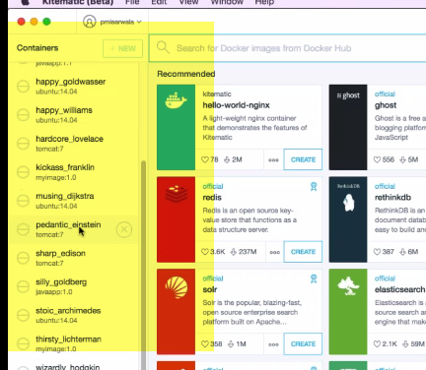

Agenda

----------------------------------------------------------------------------------------------------

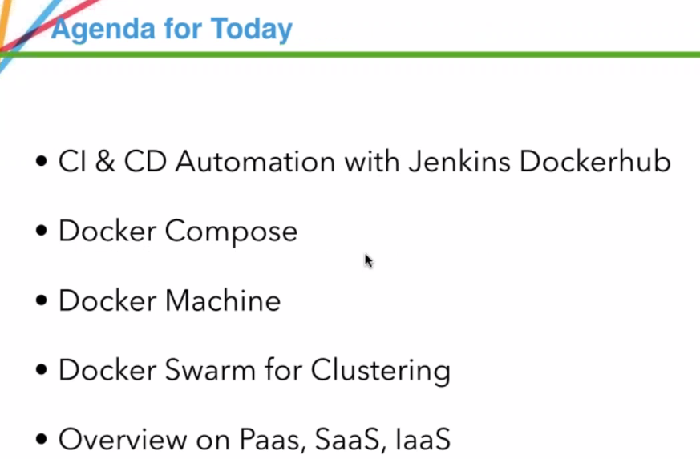

Automated builds

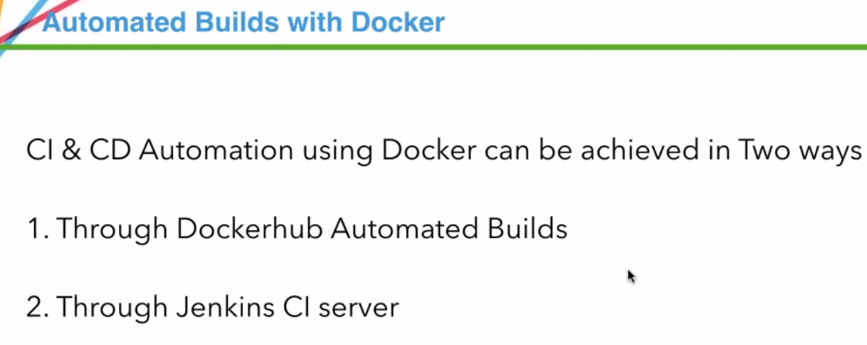

Automation meaning: When I check-in source code, build should start & image should be available and deployed on dockerhub



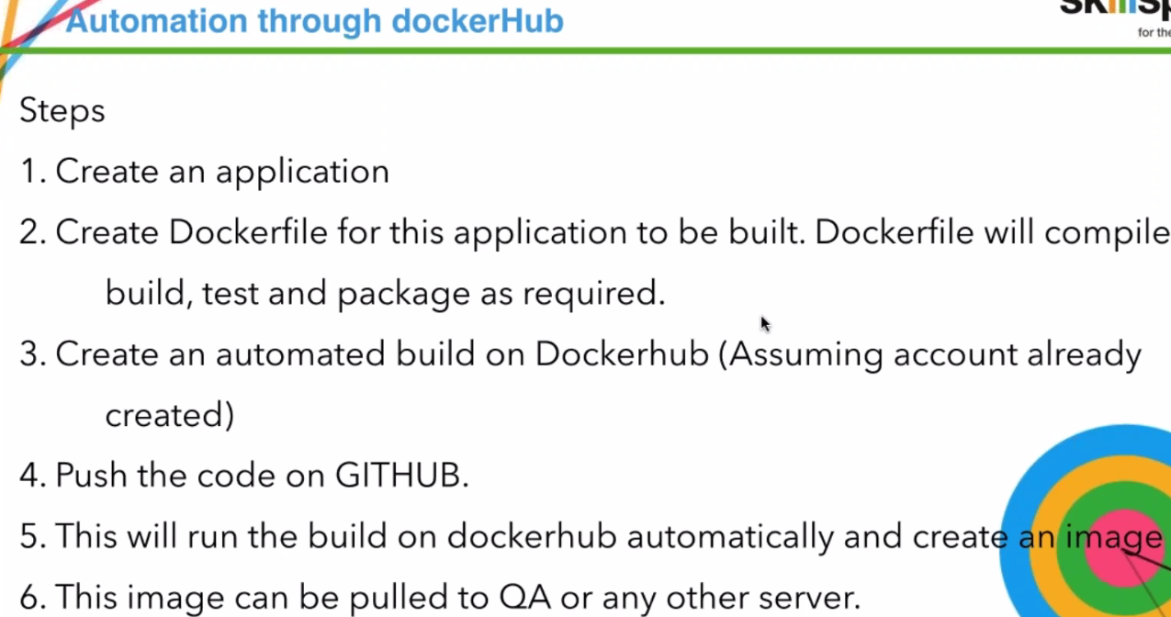

1. We use simple java application
2. Dockerfile instructions to create image
3. Create automated build on dockerhub
4. Change code, & push to github
5. Build will run automatically & create image
6. QA team pulls it